Corporate Finance, (Berk/DeMarzo)
Chapter 25 Leasing

25.1 The Basics of Leasing

1) Which of the following statements is FALSE?
A) A lease is a contract between two parties: the lessee and the lessor.
B) Most leases involve little or no upfront payment.
C) The lessee is the owner of the asset, who is entitled to the lease payments in exchange for lending the asset.
D) At the end of the contract term, the lease specifies who will retain ownership of the asset and at what terms.
Answer: C
Explanation: C) The lessor is the owner of the asset, who is entitled to the lease payments in exchange for lending the asset.
Diff: 1
Section: 25.1 The Basics of Leasing
Skill: Conceptual

2) Which of the following statements is FALSE?
A) In a direct lease, the lessor is the manufacturer (or a primary dealer) of the asset.
B) The lease specifies any cancellation provisions, the options for renewal and purchase, and the obligations for maintenance and related servicing costs.
C) If a firm already owns an asset it would prefer to lease, it can arrange a sale and leaseback transaction.
D) With many leases, the lessor provides the initial capital necessary to purchase the asset, and then receives and retains the lease payments.
Answer: A
Explanation: A) In a direct lease, the lessor is an independent company that owns the asset.
Diff: 2
Section: 25.1 The Basics of Leasing
Skill: Conceptual

3) Which of the following statements is FALSE?
A) In a leveraged lease the lessor borrows from a bank or other lender to obtain the initial capital for the purchase, using the lease payments to pay interest and principal on the loan.
B) In some circumstances, the lessor is not an independent company but rather a separate business partnership, called a special-purpose entity (SPE), which is created by the lessor for the sole purpose of obtaining the lease.
C) In a direct lease, the lessor is not the manufacturer, but is often an independent company that specializes in purchasing assets and leasing them to customers.
D) SPEs are commonly used in synthetic leases, which are designed to obtain specific accounting and tax treatment.
Answer: B
Explanation: B) In some circumstances, the lessee is not an independent company but rather a separate business partnership, called a special-purpose entity (SPE), which is created by the lessee for the sole purpose of obtaining the lease.
Diff: 3
Section: 25.1 The Basics of Leasing
Skill: Conceptual
4) A lease that gives the lessee the option to purchase the asset at its fair market value at the termination of the lease is called a:
A) fair market value cap lease.
B) fair market value lease.
C) $1.00 out lease.
D) fixed price lease.
Answer: B
Diff: 1
Section: 25.1 The Basics of Leasing
Skill: Definition

5) A lease where ownership of the asset transfers to the lessee at the end of the lease for a nominal cost is called a:
A) fair market value cap lease.
B) fixed price lease.
C) $1.00 out lease.
D) fair market value lease.
Answer: C
Diff: 1
Section: 25.1 The Basics of Leasing
Skill: Definition

6) A lease where the lessee has the option to purchase the asset at the end of the lease for a set price that is set upfront in the lease contract is called a:
A) fixed price lease.
B) $1.00 out lease.
C) fair market value lease.
D) fair market value cap lease.
Answer: A
Diff: 1
Section: 25.1 The Basics of Leasing
Skill: Definition

7) A lease where the lessee can purchase the asset at the minimum of its fair market value and a fixed price is called a:
A) $1.00 out lease.
B) fixed price lease.
C) fair market value lease.
D) fair market value cap lease.
Answer: D
Diff: 1
Section: 25.1 The Basics of Leasing
Skill: Definition
8) Which of the following statements is FALSE?
A) Because we are getting the entire asset when we purchase it with the loan, the loan payments are higher than the lease payments.
B) In a perfect market, the cost of leasing and then purchasing the asset is equivalent to the cost of borrowing to purchase the asset.
C) With a lease we are financing the entire cost of the asset, with a standard loan we are financing only the cost of the economic depreciation of the asset during its life.
D) The amount of the lease payment will depend on the purchase price, the residual value, and the appropriate discount rate for the cash flows.
Answer: C
Explanation: C) With a standard loan we are financing the entire cost of the asset, with a lease we are financing only the cost of the economic depreciation of the asset during its life.
Diff: 2
Section: 25.1 The Basics of Leasing
Skill: Conceptual

9) Which of the following statements is FALSE?
A) Absent market imperfections, leases represent another form of zero-NPV financing available to a firm, and the Modigliani-Miller propositions apply: Leases neither increase nor decrease firm value, but serve only to divide the firm's cash flows and risks in different ways.
B) In a perfect market, the cost of leasing is equivalent to the cost of purchasing and reselling the asset.
C) Each lease agreement can be tailored to fit the precise nature of the asset and the needs of the parties at hand.
D) Features of leases will be priced as part of the lease payment. Terms that give valuable options to the lessee lower the amount of the lease payments, whereas terms that restrict these options will raise them.
Answer: D
Explanation: D) Features of leases will be priced as part of the lease payment. Terms that give valuable options to the lessee raise the amount of the lease payments, whereas terms that restrict these options will lower them.
Diff: 2
Section: 25.1 The Basics of Leasing
Skill: Conceptual

10) Which of the following statements is FALSE?
A) Leases may include early cancellation options that allow the lessee to end the lease early (perhaps for a fee).
B) The cost of the lease will depend on the asset's residual value, which is its book value at the end of the lease.
C) Leases may allow the lessee to trade in and upgrade the equipment to a newer model at certain points in the lease.
D) Leases may contain buyout options that allow the lessee to purchase the asset before the end of the lease term.
Answer: B
Explanation: B) The cost of the lease will depend on the asset's residual value, which is its market value at the end of the lease.
Diff: 2
Section: 25.1 The Basics of Leasing
Skill: Conceptual
Use the information for the question(s) below.

Suppose the purchase price of a bulldozer is $90,000, its residual value in four years is certain to be $15,000, and there is no risk that the lessee will default on the lease. Assume that capital markets are perfect and the risk-free interest rate is 6% APR with monthly compounding.

11) The monthly lease payments for a four year lease of the Bulldozer are closest to:
A) $1,870
B) $1,825
C) $1,750
D) $2,115
Answer: B
Explanation: B) Set calculator to BEG mode (Annuity Due mode)
PV = 90,000
FV = -15,000
N = 48 (4 years × 12 months/year)
I = .5 (6%/12 months)
Compute PMT = $1827.24
Diff: 2
Section: 25.1 The Basics of Leasing
Skill: Analytical

12) Suppose that instead of leasing the bulldozer, the company is considering purchasing a bulldozer outright by borrowing the purchase price using a four-year annuity loan. The monthly loan payments for a four year loan to purchase the Bulldozer are closest to:
A) $2,115
B) $1,825
C) $1,870
D) $1,750
Answer: A
Explanation: A) Set calculator to END mode (Ordinary Annuity mode)
PV = 90,000
FV = 0
N = 48 (4 years × 12 months/year)
I = .5 (6%/12 months)
Compute PMT = $2113.65
Diff: 2
Section: 25.1 The Basics of Leasing
Skill: Analytical

13) Calculate the monthly lease payments for a four year $1.00 out lease of the Bulldozer.
Answer: Set calculator to BEG mode (Annuity Due mode)
PV = 90,000
FV = -1
N = 48 (4 years × 12 months/year)
I = .5 (6%/12 months)
Compute PMT = $2103.12
Diff: 2
Section: 25.1 The Basics of Leasing
Skill: Analytical
14) Calculate the monthly lease payments for a four year fixed price lease that allows the lessee to buy the Bulldozer at the end of the lease for $8,000.
Answer: Set calculator to BEG mode (Annuity Due mode)
PV = 90,000
FV = -8000
N = 48 (4 years × 12 months/year)
I = .5 (6%/12 months)
Compute PMT = $1955.99
Diff: 2
Section: 25.1 The Basics of Leasing
Skill: Analytical

25.2 Accounting, Tax, and Legal Consequences of Leasing

1) The lease is treated as a capital lease (financial lease) for the lessee and must be listed on the firm's balance sheet if it satisfies any of the following conditions EXCEPT:
A) the lease contains an option to purchase the asset at its fair market value.
B) the present value of the minimum lease payments at the start of the lease is 90% or more of the asset's fair market value.
C) the title to the property transfers to the lessee at the end of the lease term.
D) the lease term is 75% or more of the estimated economic life of the asset.
Answer: A
Diff: 2
Section: 25.2 Accounting, Tax, and Legal Consequences of Leasing
Skill: Conceptual

2) A lease will be treated as a non-tax lease if it satisfies any of the following conditions EXCEPT:
A) the property may be acquired the fair market value of the asset at the time when the option may be exercised.
B) some portion of the lease payments is specifically designated as interest or its equivalent.
C) the lessee receives ownership of the asset on completion of all lease payments.
D) the total amount that the lessee is required to pay for a relatively short period of use constitutes an inordinately large proportion of the total value of the asset.
Answer: A
Diff: 2
Section: 25.2 Accounting, Tax, and Legal Consequences of Leasing
Skill: Conceptual

3) Which of the following statements regarding operating leases is FALSE?
A) They are also called a finance leases.
B) The lease is viewed as a rental for accounting purposes.
C) The lessee reports the entire lease payment as an operating expense.
D) They are disclosed in the footnotes of the lessee's financial statements.
Answer: A
Diff: 1
Section: 25.2 Accounting, Tax, and Legal Consequences of Leasing
Skill: Conceptual
4) Which of the following statements regarding capital leases is FALSE?
A) Because capital leases increase the apparent leverage on the firm's balance sheet, firms sometimes prefer to have a lease categorized as an operating lease to keep it off the balance sheet.
B) The firm does not report the present value of the future lease payments as a liability on the balance sheet.
C) The asset acquired is listed on the lessee's balance sheet, and the lessee incurs depreciation expenses for the asset.
D) They are viewed as an acquisition for accounting purposes.
Answer: B
Explanation: B) The firm does report the present value of the future lease payments as a liability on the balance sheet.
Diff: 1
Section: 25.2 Accounting, Tax, and Legal Consequences of Leasing
Skill: Conceptual

5) Which of the following statements is FALSE?
A) The decision to lease is often driven by real-world market imperfections related to leasing's accounting, tax, and legal treatment.
B) When publicly traded firms disclose leasing transactions in their financial statements, they must follow the recommendations of the Financial Accounting Standards Board (FASB).
C) In its Statement of Financial Accounting Standards No. 13 (FAS13), the FASB provides specific criteria that distinguish a true tax lease from a non-tax lease.
D) The categories used to report leases on the financial statements affect the values of assets on the balance sheet, but they have no direct effect on the cash flows that result from a leasing transaction.
Answer: C
Explanation: C) The IRS provides specific criteria that distinguish a true tax lease from a non-tax lease.
Diff: 2
Section: 25.2 Accounting, Tax, and Legal Consequences of Leasing
Skill: Conceptual

6) Which of the following statements is FALSE?
A) If the lease is deemed to be a true lease, the firm is assumed to have effective ownership of the asset and the asset is protected against seizure.
B) Although the legal ownership of the asset resides with the lessor, in a non-tax lease the lessee receives the depreciation deductions.
C) The treatment of leased property in bankruptcy will depend on whether the lease is classified as a security interest or a true lease by the bankruptcy judge.
D) In a non-tax lease, the interest portion of the lease payment is interest income for the lessor.
Answer: A
Explanation: A) If the lease is deemed to be a security interest, the firm is assumed to have effective ownership of the asset and the asset is protected against seizure.
Diff: 2
Section: 25.2 Accounting, Tax, and Legal Consequences of Leasing
Skill: Conceptual
7) Which of the following statements regarding leases and bankruptcy is FALSE?
A) Operating and true tax leases are generally viewed as true leases by the courts, whereas capital and non-tax leases are more likely to be viewed as a security interest.
B) By retaining ownership of the asset, the lessor has the right to repossess it if the lease payments are not made, even if the firm seeks bankruptcy protection.
C) If a lease contract is characterized as a true lease in bankruptcy, the lessor is in a somewhat superior position than a lender if the firm defaults.
D) If the lease is classified as a true lease in bankruptcy, then the lessee retains ownership rights over the asset.
Answer: D
Explanation: D) If the lease is classified as a true lease in bankruptcy, then the lessor retains ownership rights over the asset.
Diff: 3
Section: 25.2 Accounting, Tax, and Legal Consequences of Leasing
Skill: Conceptual

8) Which of the following statements regarding leases and taxes is FALSE?
A) In a non-tax lease, the lessee can deduct the interest portion of the lease payments as an interest expense.
B) In a true tax lease, the lease payments are treated as revenue for the lessor.
C) In a true tax lease, the lessee receives the depreciation deductions associated with the ownership of the asset.
D) The IRS separates leases into two broad categories: true tax leases and non-tax leases.
Answer: C
Explanation: C) In a true tax lease, the lessor receives the depreciation deductions associated with the ownership of the asset.
Diff: 2
Section: 25.2 Accounting, Tax, and Legal Consequences of Leasing
Skill: Conceptual
Use the table for the question(s) below.

Luther Industries currently has the following balance sheet (in Thousands of dollars):

Assets |  | Liabilities
Cash | $500 | Debt | $4,500
Property, Plant, and Equipment | $7,000 | Equity | $3,000
Total Assets | $7,500 | Total Debt plus Equity | $7,500

Luther is about to add a new fleet of delivery trucks. The price of the fleet is $1.5 million.

9) If Luther acquires the new fleet of delivery trucks using a capital lease, Luther's Debt to Equity ratio will be closest to:
A) 0.66
B) 1.5
C) 0.80
D) 2.0
Answer: D
Explanation: D) If the firm acquires the fleet through a capital lease it is the same as if Luther borrowed the money and purchased the fleet directly. The fleet is must be listed as an asset and the lease will show up as a liability. Therefore, Luther's balance sheet will look like:

Assets |  | Liabilities
Cash | $500 | Debt | $6,000
Property, Plant, and Equipment | $8,500 | Equity | $3,000
Total Assets | $9,000 | Total Debt plus Equity | $9,000

Luther's Debt to Equity ratio therefore is equal to 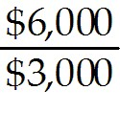 = 2.0
Diff: 2
Section: 25.2 Accounting, Tax, and Legal Consequences of Leasing
Skill: Analytical
10) If Luther acquires the new fleet of delivery trucks using an operating lease, Luther's Debt to Equity ratio will be closest to:
A) 2.0
B) 1.5
C) 0.80
D) 0.66
Answer: B
Explanation: B) If the firm acquires the fleet through an operating lease, there is no change in the original balance sheet. The fleet is not listed as an asset and the lease is not view as a liability. The transaction is off-balance sheet and will be disclosed in a foot-note. Therefore, Luther's balance sheet will look like:

Assets |  | Liabilities
Cash | $500 | Debt | $4,500
Property, Plant, and Equipment | $7,000 | Equity | $3,000
Total Assets | $7,500 | Total Debt plus Equity | $7,500

Luther's Debt to Equity ratio therefore is equal to 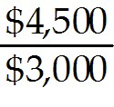 = 1.5
Diff: 2
Section: 25.2 Accounting, Tax, and Legal Consequences of Leasing
Skill: Analytical

11) What will Luther's balance sheet look like if they acquire the new fleet of delivery trucks using a capital lease?
Answer: If the firm acquires the fleet through a capital lease it is the same as if Luther borrowed the money and purchased the fleet directly. The fleet is must be listed as an asset and the lease will show up as a liability. Therefore, Luther's balance sheet will look like:

Assets |  | Liabilities
Cash | $500 | Debt | $6,000
Property, Plant, and Equipment | $8,500 | Equity | $3,000
Total Assets | $9,000 | Total Debt plus Equity | $9,000
Diff: 2
Section: 25.2 Accounting, Tax, and Legal Consequences of Leasing
Skill: Analytical
12) What will Luther's balance sheet look like if they acquire the new fleet of delivery trucks using an operating lease?
Answer: If the firm acquires the fleet through an operating lease, there is no change in the original balance sheet. The fleet is not listed as an asset and the lease is not view as a liability. The transaction is off-balance sheet and will be disclosed in a foot-note. Therefore, Luther's balance sheet will look like:

Assets |  | Liabilities
Cash | $500 | Debt | $4,500
Property, Plant, and Equipment | $7,000 | Equity | $3,000
Total Assets | $7,500 | Total Debt plus Equity | $7,500
Diff: 2
Section: 25.2 Accounting, Tax, and Legal Consequences of Leasing
Skill: Analytical
25.3 The Leasing Decision

Use the following information to answer the question(s) below.

Rearden Metal is considering the purchase of a new blast furnace costing a total of $5 million dollars. This furnace will qualify for accelerated depreciation: 20% can be expense immediately, followed by 32%, 19.2%, 11.52%, 11.52% and 5.76% over the next five years. However, because of Rearden's substantial tax loss carry forwards, Rearden estimates its marginal tax rate to be only 10% over the next five years. Since Rearden will get very little tax benefit from the depreciation expense, they consider leasing the furnace instead. Suppose that Rearden and the lessor face the same 8% borrowing rate, but the lessor has a 40% marginal tax rate. Assume that the furnace is worthless after five years, the lease term is five years, and a lease would qualify as a true tax lease.

1) Assuming that Rearden's annual lease payments are $1.1 million, then the effective after-tax lease borrowing rate is closest to:
A) 8.0%
B) 12.8%
C) 15.4%
D) 17.0%
Answer: D
Explanation: D)
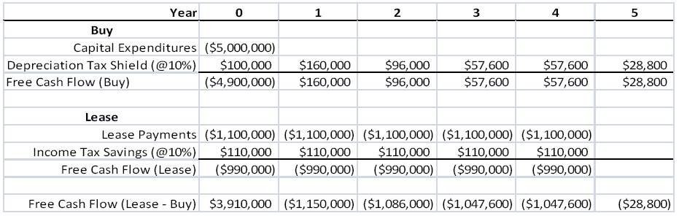
NPV = PV(FCF Lease - Buy) at rd(1 - Tc) = 8%(1 - .10) = 7.2%

NPV= 0 = 3,910,000 - 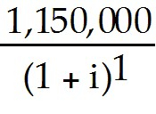 - 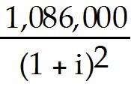 - 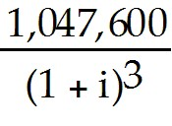 - 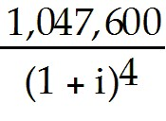 - 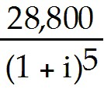
Solving for i we get 17.02%.
Diff: 3
Section: 25.3 The Leasing Decision
Skill: Analytical
2) Assuming that Rearden's annual lease payments are $1.2 million, then the amount of the lease-equivalent loan is closest to:
A) $3.8 million
B) $3.9 million
C) $4.0 million
D) $4.2 million
Answer: C
Explanation: C)
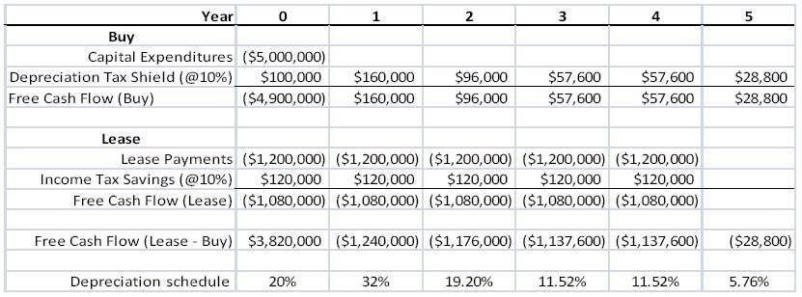
Loan Balance = PV(Future FCF Lease - Buy) at rd(1 - Tc) = 8%(1 - .10) = 7.2%

Loan Balance = 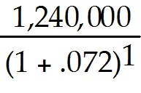 + 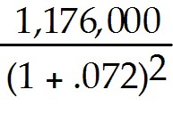 + 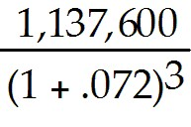 + 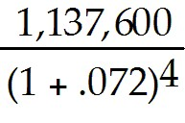 + 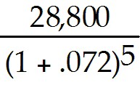
= $3,985,238
Diff: 3
Section: 25.3 The Leasing Decision
Skill: Analytical

3) Assuming that Rearden's annual lease payments are $1.2 million, then the amount of the savings in year 0 from leasing is closest to:
A) $3.8 million
B) $3.9 million
C) $4.0 million
D) $4.2 million
Answer: A
Explanation: A)
The amount is the FCF of lease - buy in year zero = 3,820,000.
Diff: 3
Section: 25.3 The Leasing Decision
Skill: Analytical
4) Assuming that Rearden's annual lease payments are $1.2 million, then use the direct method, the NPV of leasing is closest to:
A) ($165,000)
B) ($95,000)
C) $0
D) $95,000
Answer: A
Explanation: A)
NPV = PV(FCF Lease - Buy) at rd(1 - Tc) = 8%(1 - .10) = 7.2%

NPV = 3,820,000 + 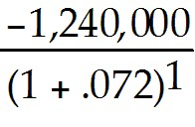 + 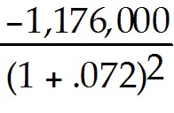 + 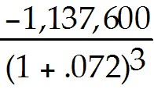 + 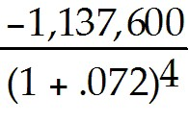 + 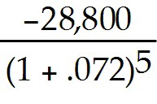
= -$165,238
Diff: 3
Section: 25.3 The Leasing Decision
Skill: Analytical
5) Assuming that Rearden's annual lease payments are $1.2 million, then the effective after-tax lease borrowing rate is closest to:
A) 7.2%
B) 8.0%
C) 8.8%
D) 9.1%
Answer: D
Explanation: D)
NPV = PV(FCF Lease - Buy) at rd(1 - Tc) = 8%(1 - .10) = 7.2%

NPV= 0 = 3,820,000 - 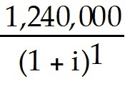 - 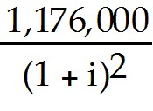 - 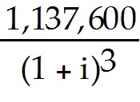 - 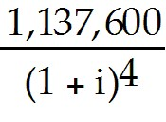 -
Solving for i we get 9.1263%.
Diff: 3
Section: 25.3 The Leasing Decision
Skill: Analytical
6) Assuming that Rearden's annual lease payments are $1.2 million, then Rearden Metal should:
A) lease the furnace since the amount saved in year zero from leasing is greater than the amount of the lease equivalent loan.
B) buy the furnace since the amount saved in year zero from leasing is greater than the amount of the lease equivalent loan.
C) lease the furnace since the amount saved in year zero from leasing is less than the amount of the lease equivalent loan.
D) buy the furnace since the amount saved in year zero from leasing is less than the amount of the lease equivalent loan.
Answer: D
Explanation: D)
Loan Balance = PV(Future FCF Lease - Buy) at rd(1 - Tc) = 8%(1 - .10) = 7.2%
Loan Balance = + + + +
= $3,985,238
The amount of savings in year zero from leasing is the FCF of lease - buy in year zero = 3,820,000.
Since the lease equivalent loan is greater, Rearden Metal should buy the furnace.
Diff: 3
Section: 25.3 The Leasing Decision
Skill: Analytical
7) Assuming that Rearden's annual lease payments are $1.1 million, then the amount of the lease-equivalent loan is closest to:
A) $3.7 million.
B) $3.8 million.
C) $3.9 million.
D) $4.0 million.
Answer: A
Explanation: A)
Loan Balance = PV(Future FCF Lease — Buy) at rd(1 — Tc) = 8%(1 - .10) = 7.2%

Loan Balance = 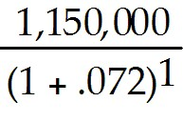 + 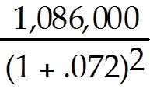 + 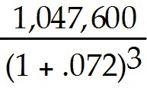 + 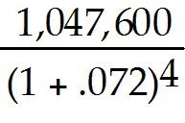 +
= $3,681,760
Diff: 3
Section: 25.3 The Leasing Decision
Skill: Analytical

8) Which of the following statements is FALSE?
A) Lease payments are a fixed obligation of the firm.
B) The risk of the lease payments is no greater than the risk of secured debt, so it is reasonable to discount the lease payments at the firm's secured borrowing rate.
C) If a firm purchases a piece of equipment, the expense is a capital expenditure. Therefore, the purchase price can be depreciated over time, generating a depreciation tax shield.
D) If the equipment is leased and the lease is a non-tax lease, there is no capital expenditure, but the lease payments are an operating expense.
Answer: D
Explanation: D) If the equipment is leased and the lease is a true tax lease, there is no capital expenditure, but the lease payments are an operating expense.
Diff: 1
Section: 25.3 The Leasing Decision
Skill: Conceptual
9) Which of the following statements is FALSE?
A) The lease-equivalent loan is the loan that is required on the purchase of the asset that leaves the purchaser with the same obligations as the lessor would have.
B) Lease obligations themselves could trigger financial distress.
C) When a firm enters into a lease, it is committing to lease payments that are a fixed future obligation of the firm.
D) When a firm leases an asset, it is effectively adding leverage to its capital structure (whether or not the lease appears on the balance sheet for accounting purposes).
Answer: A
Explanation: A) The lease-equivalent loan is the loan that is required on the purchase of the asset that leaves the purchaser with the same obligations as the lessee would have.
Diff: 1
Section: 25.3 The Leasing Decision
Skill: Conceptual

10) Which of the following statements is FALSE?
A) We can compare leasing to buying the asset using equivalent leverage by discounting the incremental cash flows of leasing versus buying using the after-tax borrowing rate.
B) A non-tax lease is attractive if it offers a better interest rate than would be available with a loan.
C) Evaluating a true tax lease is much more straightforward than evaluating a non-tax lease.
D) To determine whether a non-tax lease offers a better rate, we discount the lease payments at the firm's pre-tax borrowing rate and compare it to the purchase price of the asset.
Answer: C
Explanation: C) Evaluating a non-tax lease is much more straightforward than evaluating a true tax lease.
Diff: 2
Section: 25.3 The Leasing Decision
Skill: Conceptual
Use the information for the question(s) below.

St. Martin's Hospital plans to purchase or lease a $2 million dollar CT scanner. If purchased, the CT scanner will be depreciated on a straight-line basis over five years, after which it will be worthless. If leased, the annual lease payments will be $500,000 per year for five years. St. Martin's borrowing cost is 8%, and its tax rate is 35%.

11) If St. Martin purchases the CT scanner, what is the amount of the lease-equivalent loan?
Answer: First we construct the FCF from leasing and buying. The FCF from leasing are the annual lease payments × (1 - τc) since these payments are deductible for tax purposes. The FCF from buying represents the original cost of the purchase in year 0 and the depreciation tax shield of ($2M/5 years) × .35. The free cash flows are as follows:

Year | 0 | 1 | 2 | 3 | 4 | 5
FCF, Lease | (325,000) | (325,000) | (325,000) | (325,000) | (325,000)
Less: FCF Buy | (2,000,000) | 140,000 | 140,000 | 140,000 | 140,000 | 140,000
Lease-Buy | 1,675,000 | (465,000) | (465,000) | (465,000) | (465,000) | (140,000)

The amount of the lease equivalent loan is equal to the present value of the difference in FCFs from years 1 to 5 discounted at the after tax borrowing rate (.08)(1 - .35) = .052 or 5.2%.

LEL = 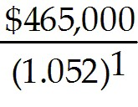 + 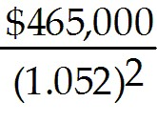 + 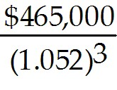 + 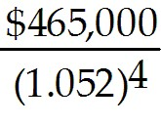 + 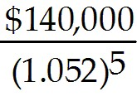 = $1,749,890
Diff: 2
Section: 25.3 The Leasing Decision
Skill: Analytical
12) Is St. Martin's better off leasing the CT scanner or financing the purchase of the CT scanner with a lease-equivalent loan and by how much is St Martin's better off?
Answer: First we construct the FCF from leasing and buying. The FCF from leasing are the annual lease payments × (1 - τc) since these payments are deductible for tax purposes. The FCF from buying represents the original cost of the purchase in year 0 and the depreciation tax shield of ($2M/5 years) × .35. The free cash flows are as follows:

Year | 0 | 1 | 2 | 3 | 4 | 5
FCF, Lease | (325,000) | (325,000) | (325,000) | (325,000) | (325,000)
Less: FCF Buy | (2,000,000) | 140,000 | 140,000 | 140,000 | 140,000 | 140,000
Lease-Buy | 1,675,000 | (465,000) | (465,000) | (465,000) | (465,000) | (140,000)

The amount of the lease equivalent loan is equal to the present value of the difference in FCFs from years 1 to 5 discounted at the after tax borrowing rate (.08)(1 - .35) = .052 or 5.2%.

LEL = + + + + = $1,749,890
Therefore, St. Martin's is better off not using the lease since 1,749,890 > 1,675,000

St. Martin's is better of by 1,749,890 - 1,650,000 = $74,890
Diff: 3
Section: 25.3 The Leasing Decision
Skill: Analytical

Use the following information to answer the question(s) below.

Rearden Metal is considering the purchase of a new blast furnace costing a total of $5 million dollars. This furnace will qualify for accelerated depreciation: 20% can be expense immediately, followed by 32%, 19.2%, 11.52%, 11.52% and 5.76% over the next five years. However, because of Rearden's substantial tax loss carry forwards, Rearden estimates its marginal tax rate to be only 10% over the next five years. Since Rearden will get very little tax benefit from the depreciation expense, they consider leasing the furnace instead. Suppose that Rearden and the lessor face the same 8% borrowing rate, but the lessor has a 40% marginal tax rate. Assume that the furnace is worthless after five years, the lease term is five years, and a lease would qualify as a true tax lease.

13) Assuming that Rearden's annual lease payments are $1.1 million, then Rearden Metal should
A) lease the furnace since the amount saved in year zero from leasing is greater than the amount of the lease equivalent loan.
B) buy the furnace since the amount saved in year zero from leasing is greater than the amount of the lease equivalent loan.
C) lease the furnace since the amount saved in year zero from leasing is less than the amount of the lease equivalent loan.
D) buy the furnace since the amount saved in year zero from leasing is less than the amount of the lease equivalent loan.
Answer: A
Explanation: A)

Loan Balance = PV(Future FCF Lease - Buy) at rd(1 - Tc) = 8%(1 - .10) = 7.2%

Loan Balance = + + + +
= $3,681,760
The amount of savings in year zero from leasing is the FCF of lease - buy in year zero = 3,910,000.
Since the lease equivalent loan is less, Rearden Metal should lease the furnace.
Diff: 3
Section: 25.3 The Leasing Decision
Skill: Analytical
25.4 Reasons for Leasing

Use the following information to answer the question(s) below.

Rearden Metal is considering the purchase of a new blast furnace costing a total of $5 million dollars. This furnace will qualify for accelerated depreciation: 20% can be expense immediately, followed by 32%, 19.2%, 11.52%, 11.52% and 5.76% over the next five years. However, because of Rearden's substantial tax loss carry forwards, Rearden estimates its marginal tax rate to be only 10% over the next five years. Since Rearden will get very little tax benefit from the depreciation expense, they consider leasing the furnace instead. Suppose that Rearden and the lessor face the same 8% borrowing rate, but the lessor has a 40% marginal tax rate. Assume that the furnace is worthless after five years, the lease term is five years, and a lease would qualify as a true tax lease.

1) The lease rate for which the lessor will break even is closest to:
A) $1,110,000
B) $1,130,000
C) $1,150,000
D) $1,160,000
Answer: C
Explanation: C)
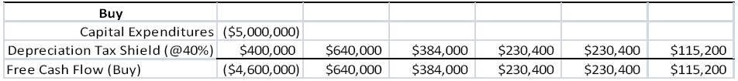

NPV = PV(FCF Lease - Buy) at rd(1 - Tc) = 8%(1 - .40) = 4.8%

NPV = PMT(1 - .4)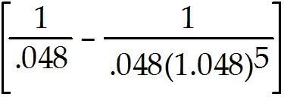(1.048) - 4,600,000 + 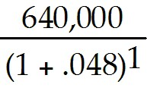 + 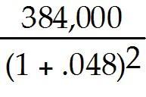 + 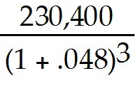 + 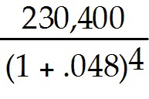 + 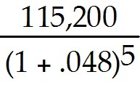

→ PMT = $1,153,386
Diff: 3
Section: 25.4 Reasons for Leasing
Skill: Analytical
2) The lease rate for which Rearden will break even is closest to:
A) $1,110,000
B) $1,130,000
C) $1,150,000
D) $1,160,000
Answer: D
Explanation: D)
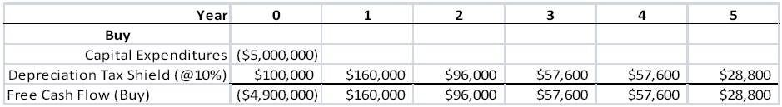
NPV = 0 = PV(FCF Lease - Buy) at rd(1 - Tc) = 8%(1 - .10) = 7.2%

NPV = PMT(1 - .1)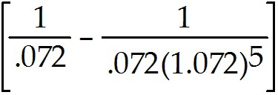(1.072) - 4,900,000 + 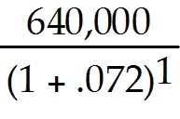 + 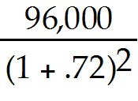 + 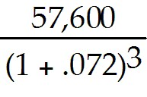 + 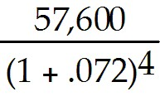 +

→ PMT =1,158,006
Diff: 3
Section: 25.4 Reasons for Leasing
Skill: Analytical

3) Which of the following statements is FALSE?
A) For a lease to be attractive to both the lessee and the lessor, the gains must come from some underlying economic benefits that the leasing arrangement provides.
B) With a true tax lease, the lessor replaces depreciation and interest tax deductions with a deduction for the lease payments.
C) Generally speaking, if the asset's tax depreciation deductions are more rapid than its lease payments, a true tax lease is advantageous if the lessor is in a higher tax bracket than the lessee.
D) A tax gain occurs if the lease shifts the more valuable deductions to the party with the higher tax rate.
Answer: B
Explanation: B) With a non-tax lease, the lessor replaces depreciation and interest tax deductions with a deduction for the lease payments
Diff: 2
Section: 25.4 Reasons for Leasing
Skill: Conceptual
4) Which of the following statements is FALSE?
A) If a firm only needs to use the asset for a short time, it is probably less costly to lease it than to buy and resell the asset.
B) While owners of assets are likely to resell them only if the assets are "lemons," a short-term lease can commit the user of an asset to return it regardless of its quality. In this way leases can help mitigate the adverse selection problem in the used goods market.
C) Car dealerships are in a better position to sell a used car at the end of a lease than a consumer is.
D) If the asset's tax depreciation deductions are faster than its lease payments, there are tax gains from a true tax lease if the lessor is in a lower tax bracket than the lessee.
Answer: D
Explanation: D) If the asset's tax depreciation deductions are slower than its lease payments, there are tax gains from a true tax lease if the lessor is in a lower tax bracket than the lessee.
Diff: 2
Section: 25.4 Reasons for Leasing
Skill: Conceptual

5) Which of the following statements is FALSE?
A) By offering assets together with complementary services, lessors can achieve efficiency gains and offer attractive lease rates.
B) Assets leased under a true lease are afforded bankruptcy protection and cannot be seized in the event of default.
C) Because of the higher recovery value in the event of default, a lessor may be able to offer more attractive financing through the lease than an ordinary lender could.
D) Lessors often have efficiency advantages over lessees in maintaining or operating certain types of assets.
Answer: B
Explanation: B) Assets leased under a true lease are not afforded bankruptcy protection and can be seized in the event of default.
Diff: 1
Section: 25.4 Reasons for Leasing
Skill: Conceptual

6) Which of the following statements is FALSE?
A) Most financial analysts and sophisticated investors consider operating leases (which must be listed in the footnotes of the financial statements) to be additional sources of leverage.
B) By carefully avoiding the four criteria that define a operating lease for accounting purposes, a firm can avoid listing the long-term lease as a liability.
C) Because a lease is equivalent to a loan, the firm can increase its actual leverage without increasing the debt-to-equity ratio on its balance sheet.
D) For most large corporations, the amount of leverage the firm can obtain through a lease is unlikely to exceed the amount of leverage the firm can obtain through a loan.
Answer: B
Explanation: B) By carefully avoiding the four criteria that define a capital lease for accounting purposes, a firm can avoid listing the long-term lease as a liability.
Diff: 2
Section: 25.4 Reasons for Leasing
Skill: Conceptual
7) Which of the following statements is FALSE?
A) Leasing allows the party best able to bear the risk to hold it. For example, small firms with a low tolerance for risk may prefer to lease rather than purchase assets.
B) When the lessor is the manufacturer, a lease in which the lessor bears the risk of the residual value can improve incentives and lower agency costs.
C) For leases in which the lessor retains a substantial interest in the asset's residual value, the lessee has more of an incentive to take proper care of an asset that is leased rather than purchased.
D) Whether they appear on the balance sheet or not, lease commitments are a liability for the firm.
Answer: C
Explanation: C) For leases in which the lessee retains a substantial interest in the asset's residual value, the lessee has more of an incentive to take proper care of an asset that is leased rather than purchased.
Diff: 2
Section: 25.4 Reasons for Leasing
Skill: Conceptual

